CREATING AND CONFIGURING IBM WATSON

IOT PLATFORM AND CREATING A DEVICE

|  |  |
| --- | --- |
| Date | 14 November 2022 |
| Team ID | PNT2022TMID51029 |
| Project Name | Gas leakage monitoring and alerting system for industries |

# Aim:

To create and configure the IBM Watson IoT platform and create a device.

**Steps to be followed:**

Step 1: Login to your IBM Cloud account and go to dashboard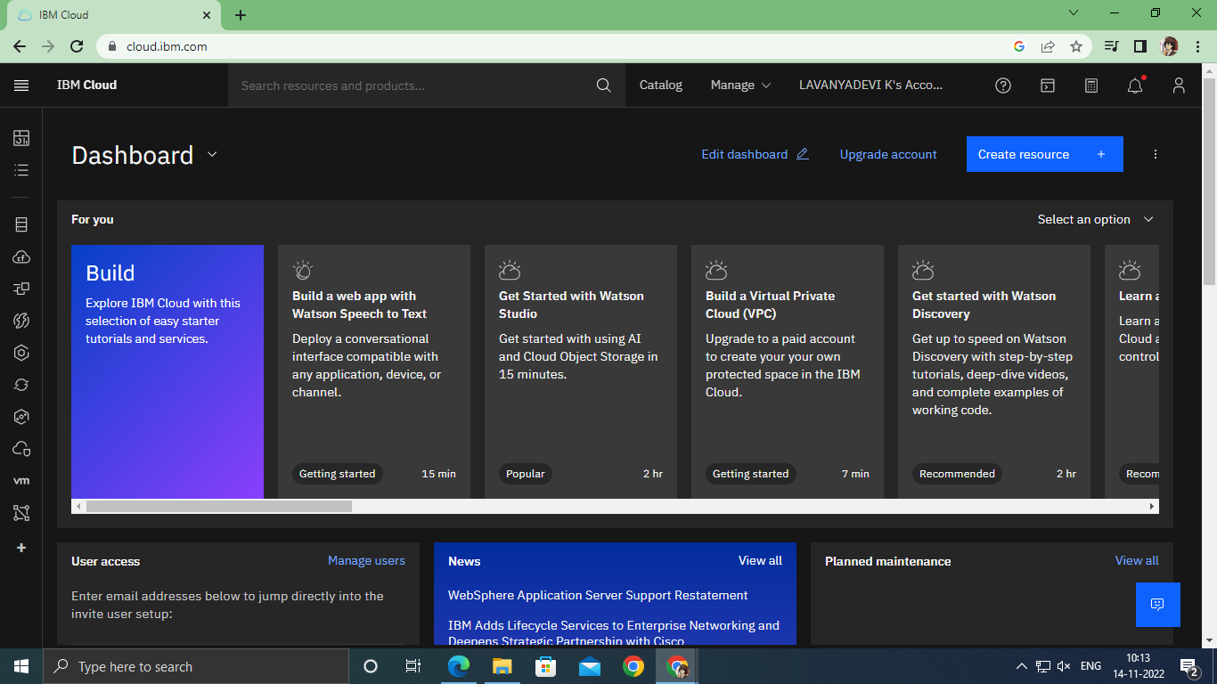

Step 2: Click on the catalog on the top.

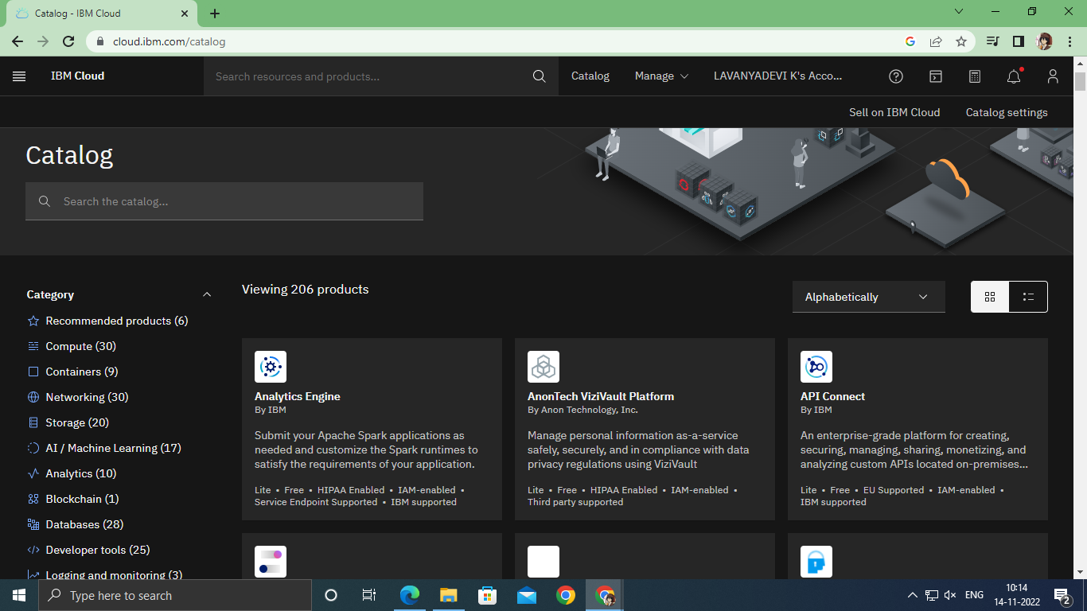

`

Step 3: Click on IoT in the category mentioned.

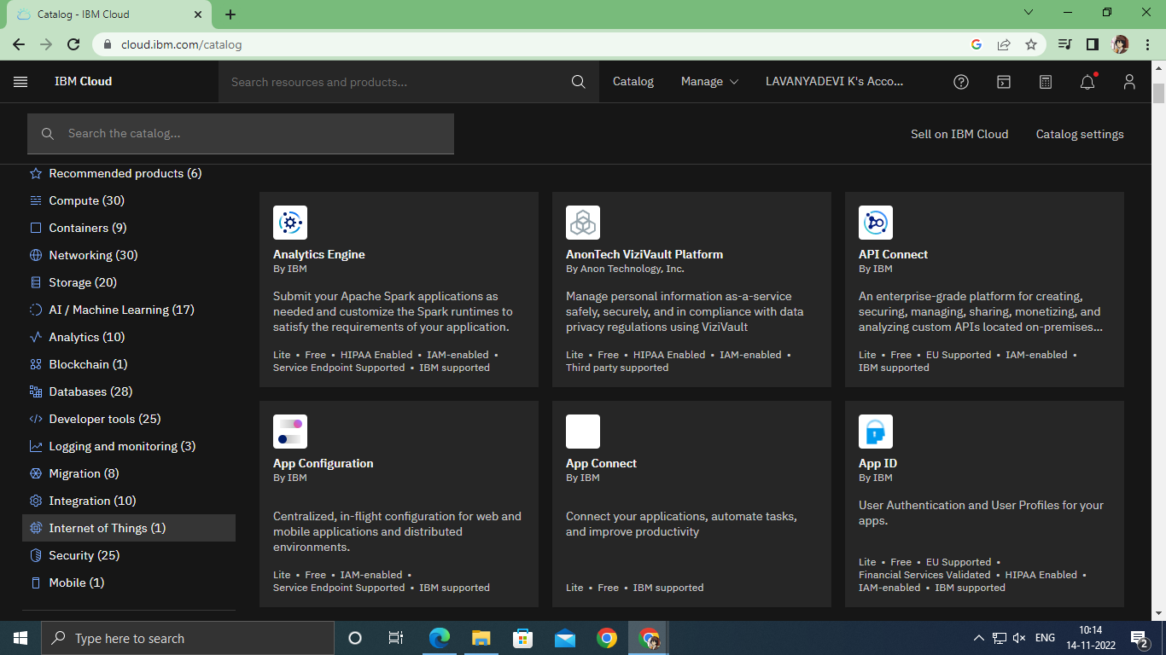

Step 4: Click on Internet of Things Platform.

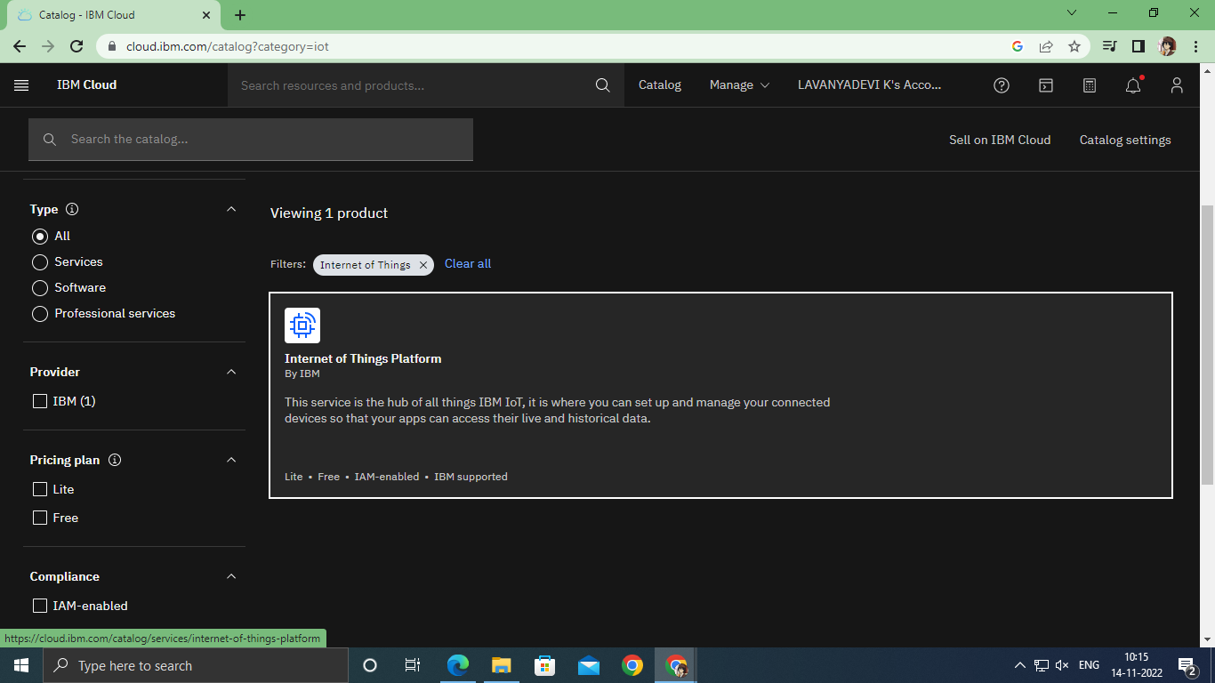

Step 5: Tick agreements and then click on create.

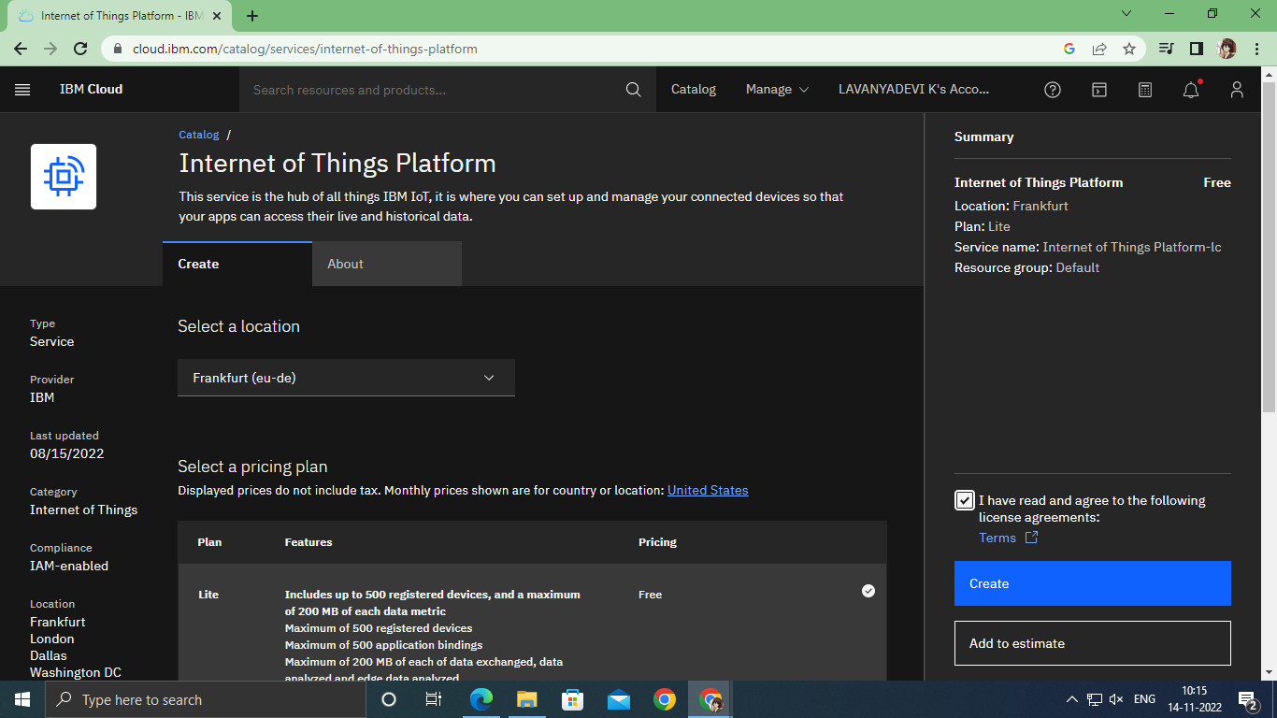

Step 6: Click on the launch button.

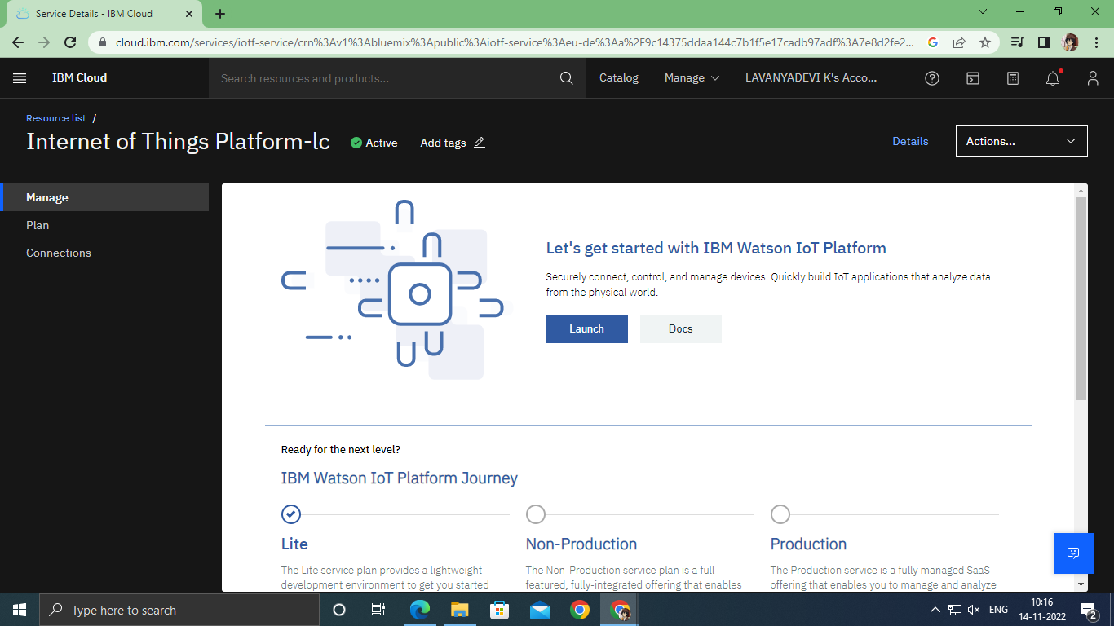

Step 7: After clicking on the launch button this tab will open and now click on sign in option

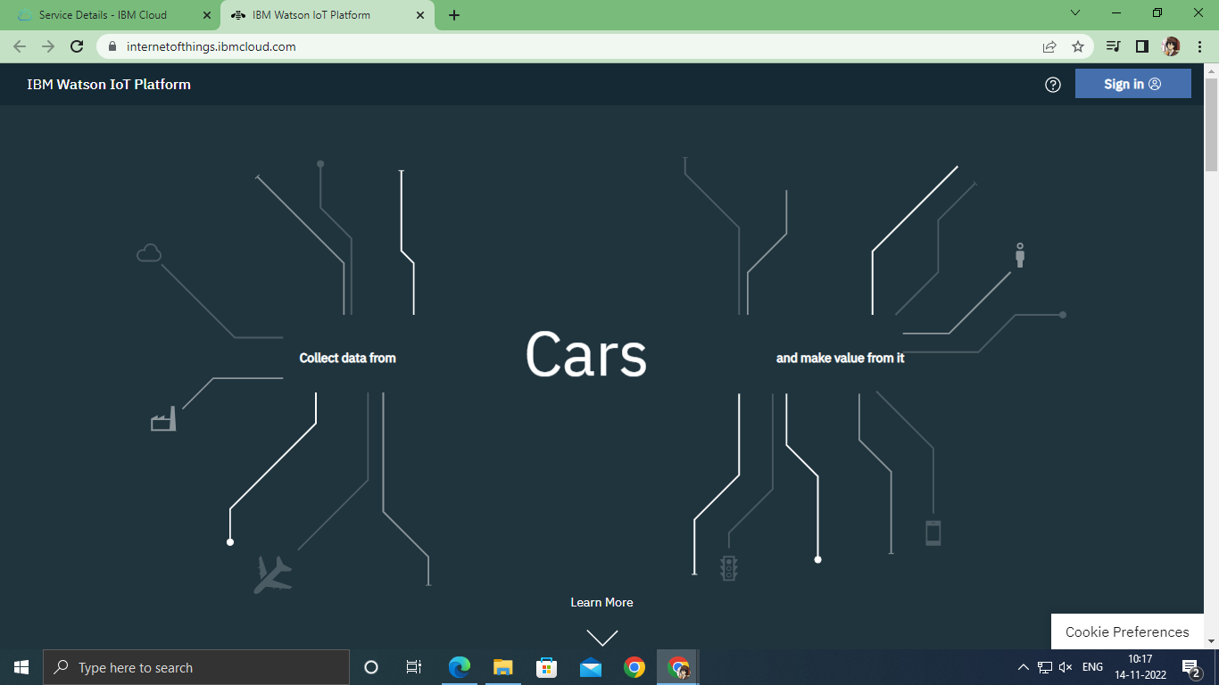

Step 8: You will be logged in after entering your credentials

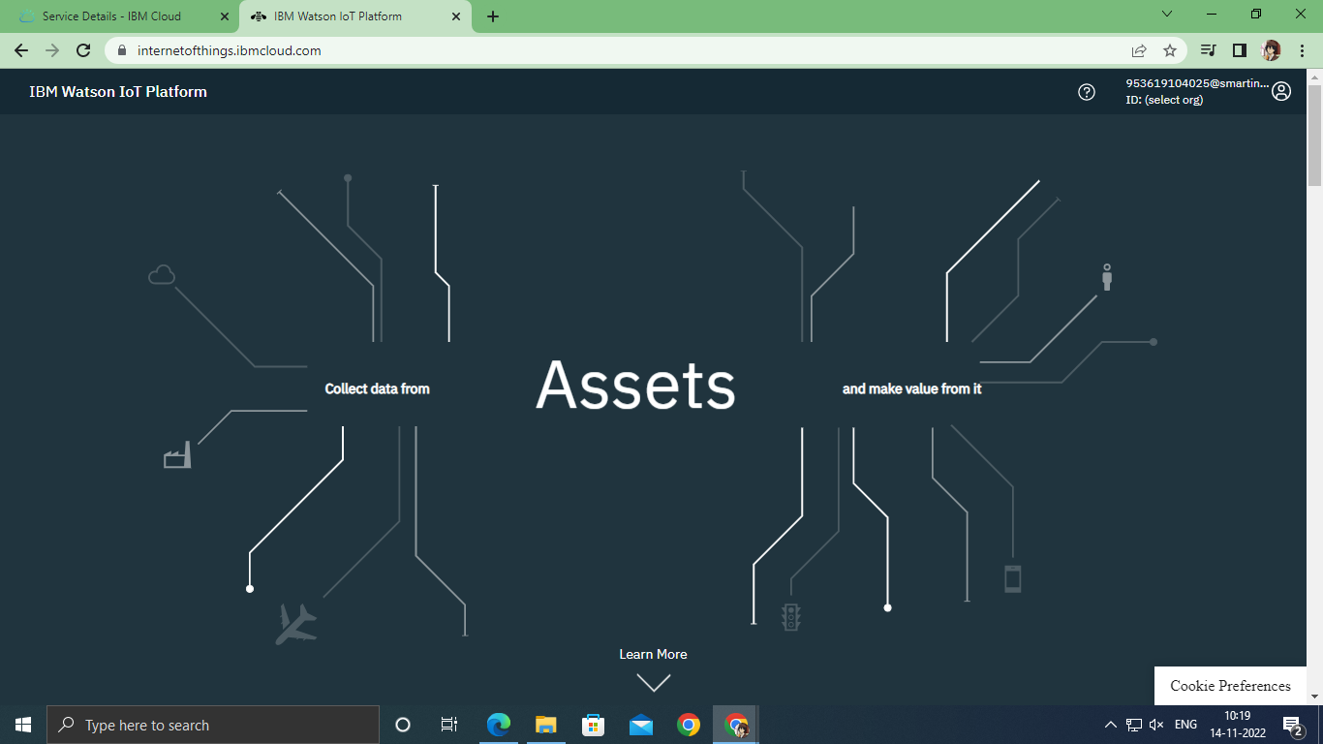

Step 9: Once it id logged in, the name will be displayed click on it and then click on Bluemix Free.

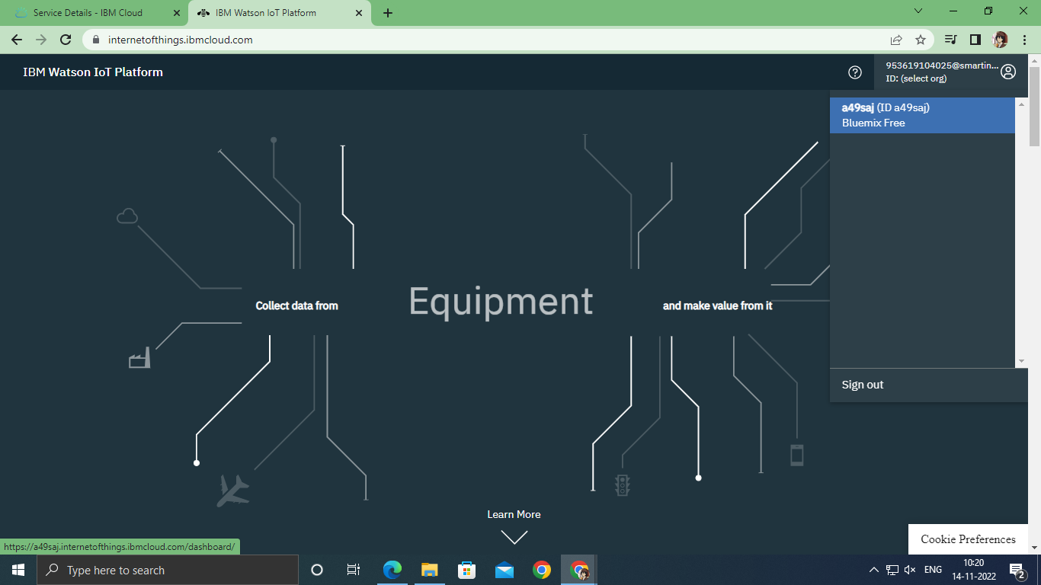

`

Step 10: This is the IBM Watson platform.

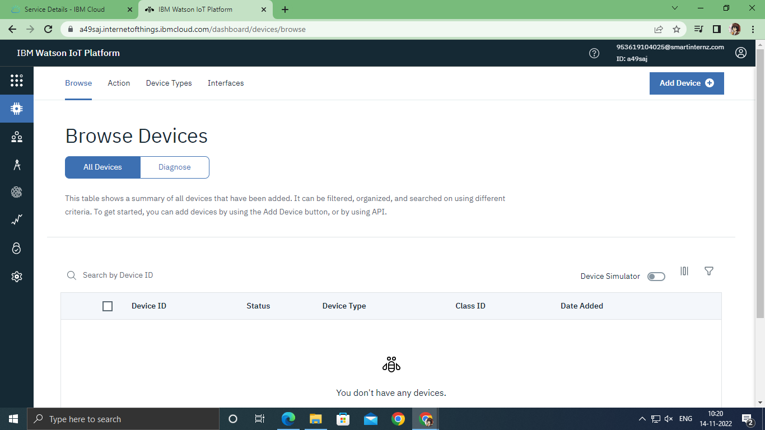

Step 11: Click on Add Device.

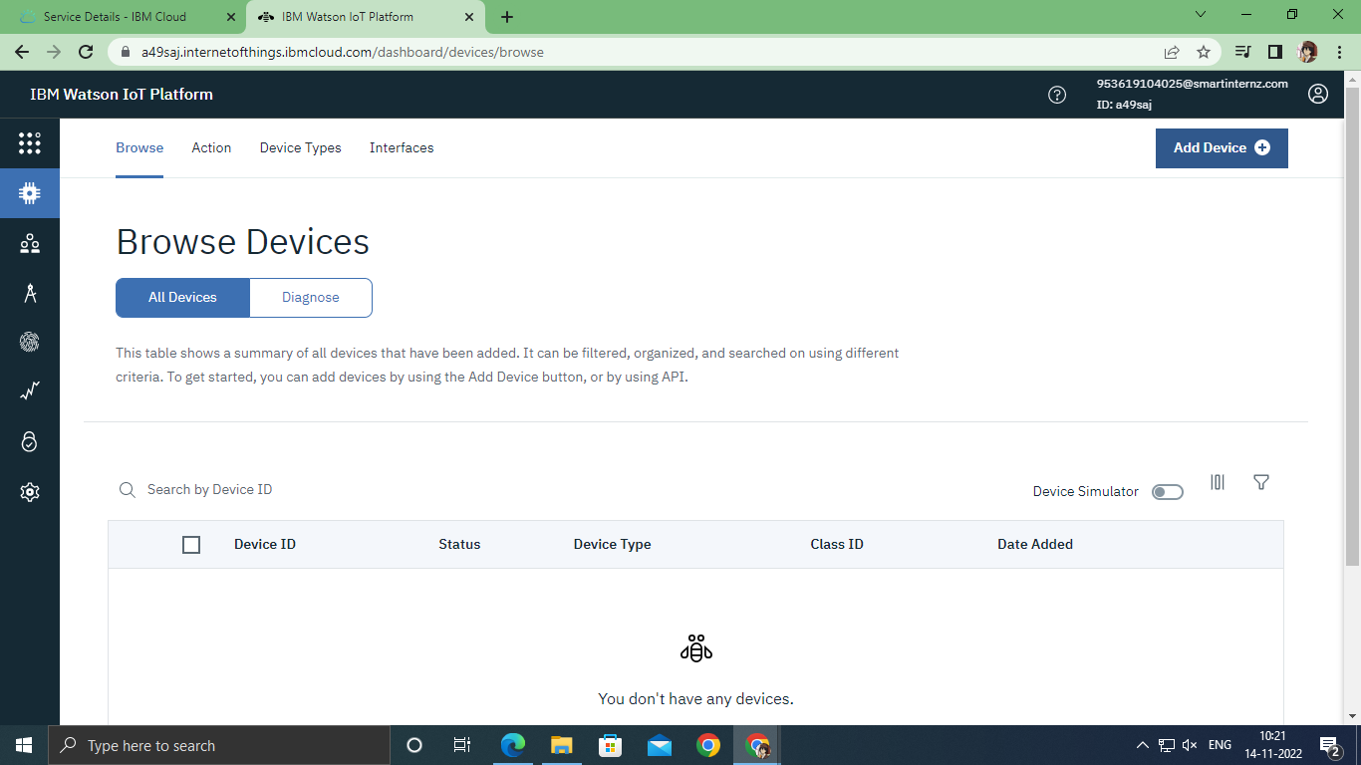

Step 12: Click on device type and register devices

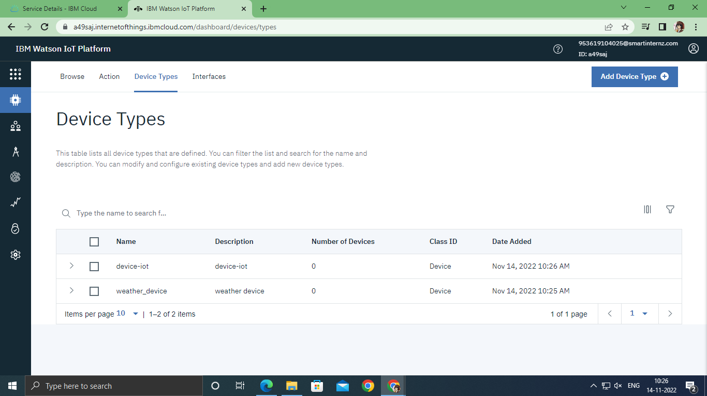

Step 13: Give the device name which you have created and give Device ID.

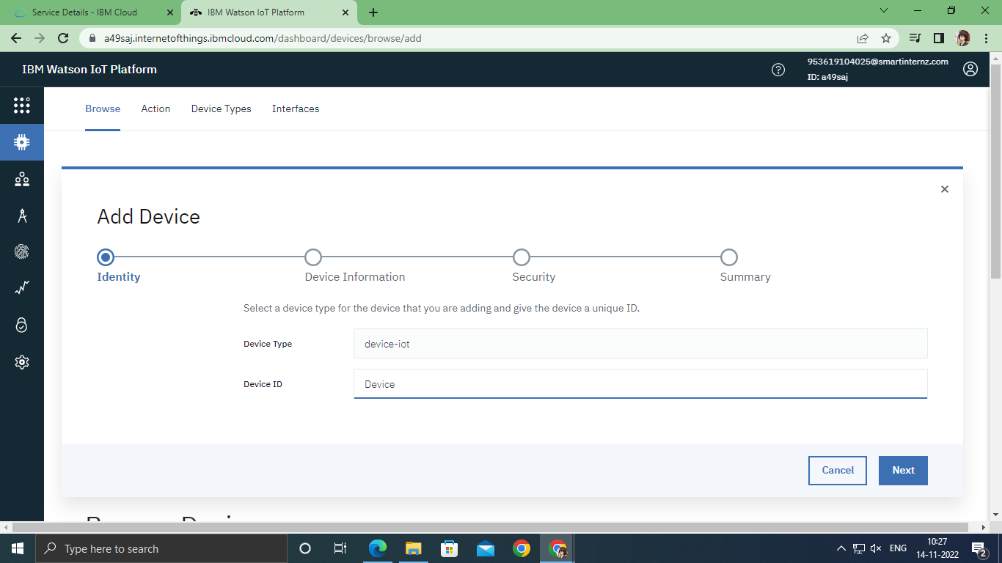

Step 14: After giving all the data, Click on next an then click on finish

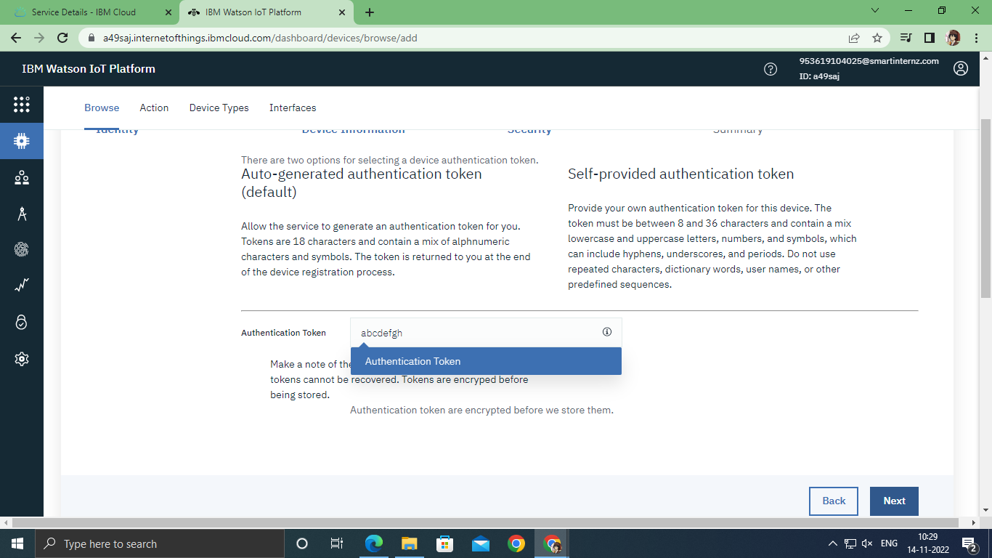

Step15: Go to settings and this page will be displayed

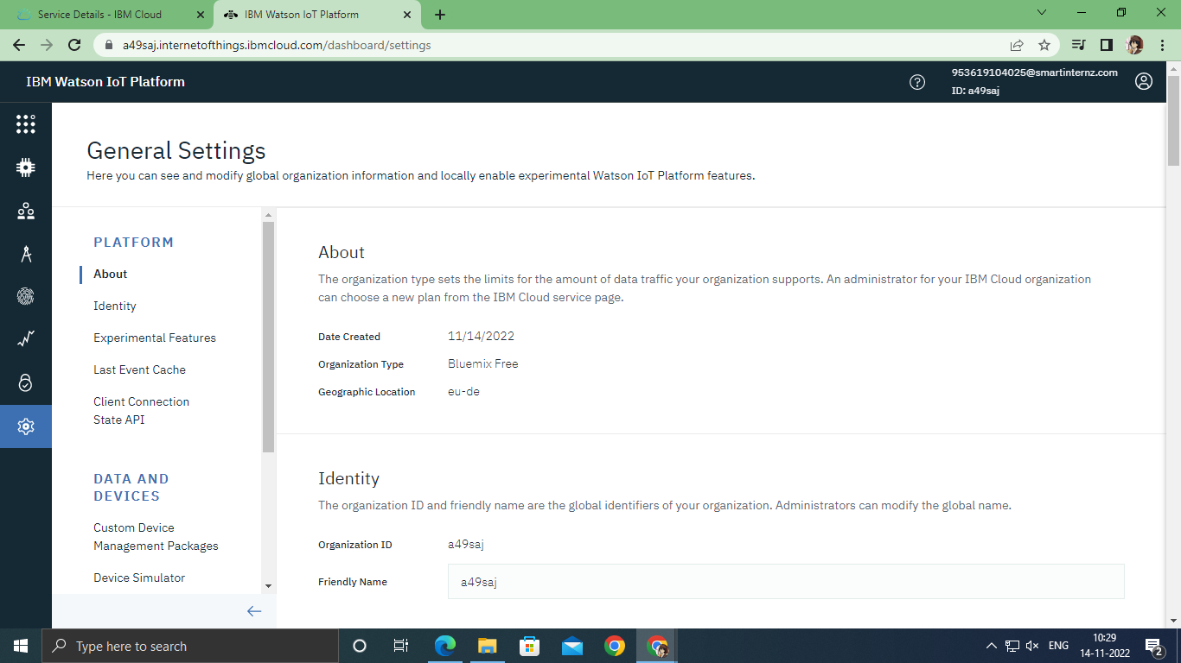

Step 16: Click on Data and Devices.

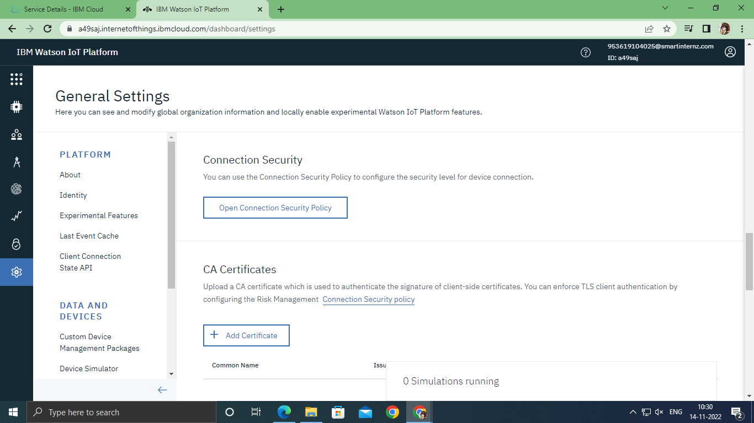

Step 17: Then click on Device Simulator and Activate Device Simulator.

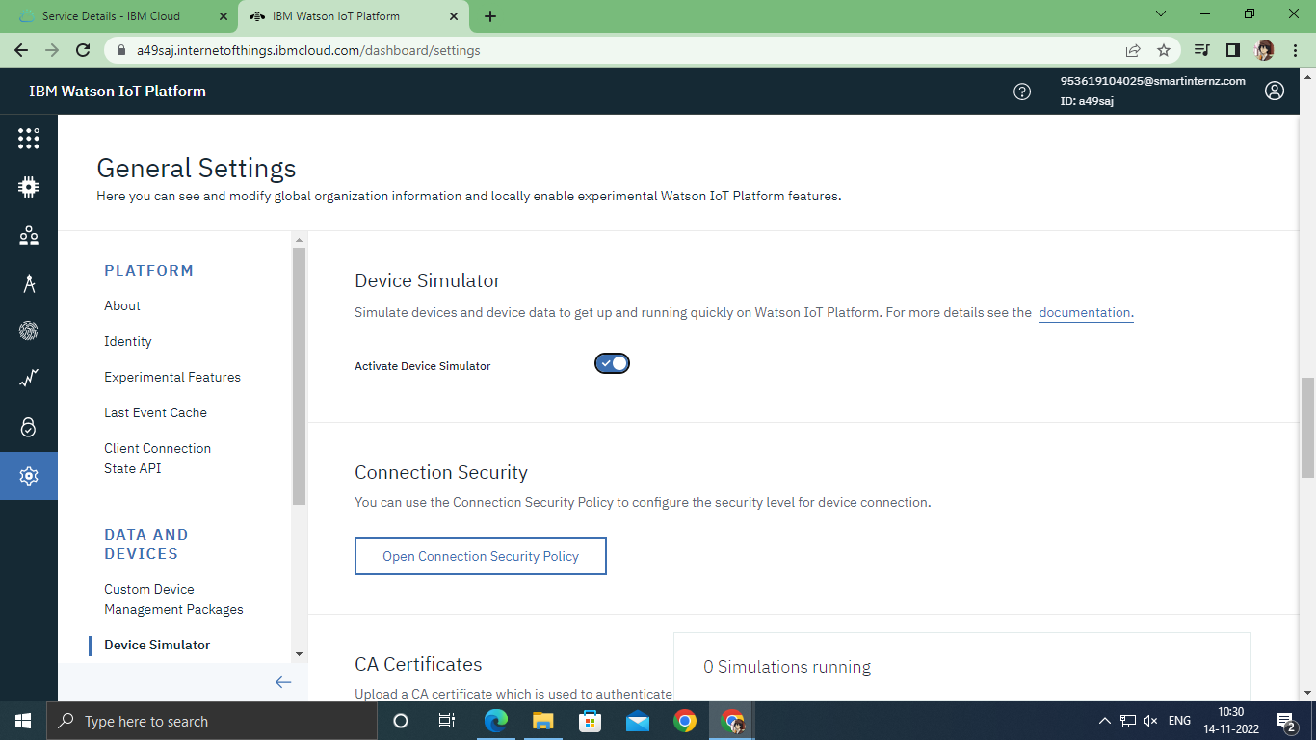

Step 18: Click on “0 simulations running” on the bottom - right side.



Step 19: This will be displayed if the device name is given

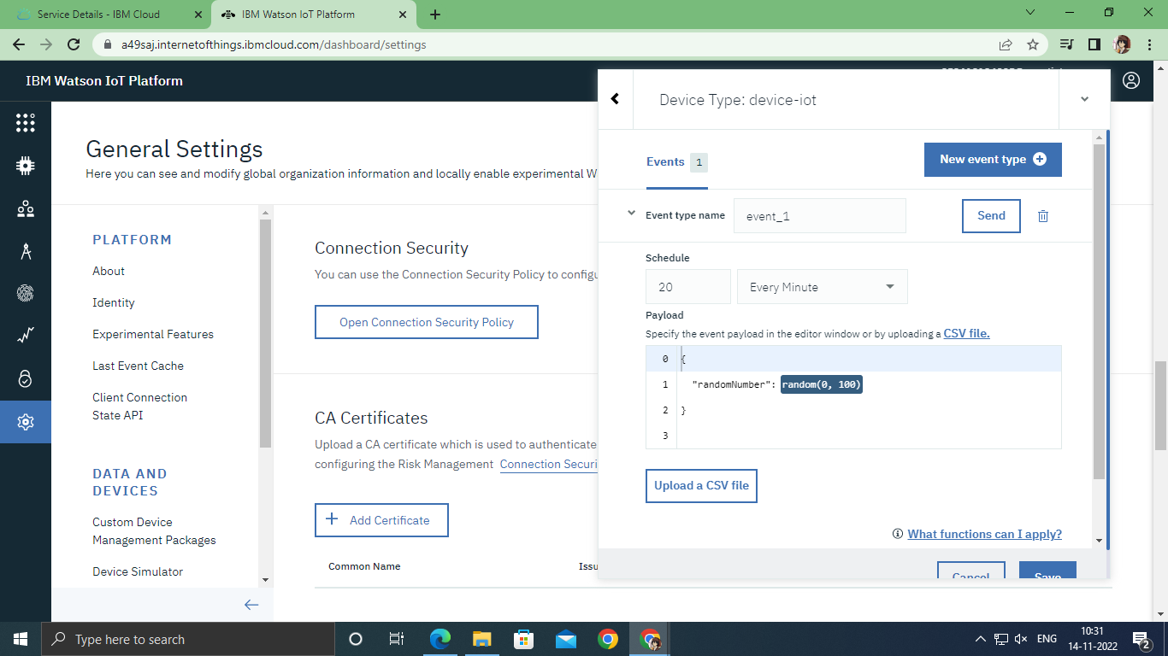

Step 20: Type the code.

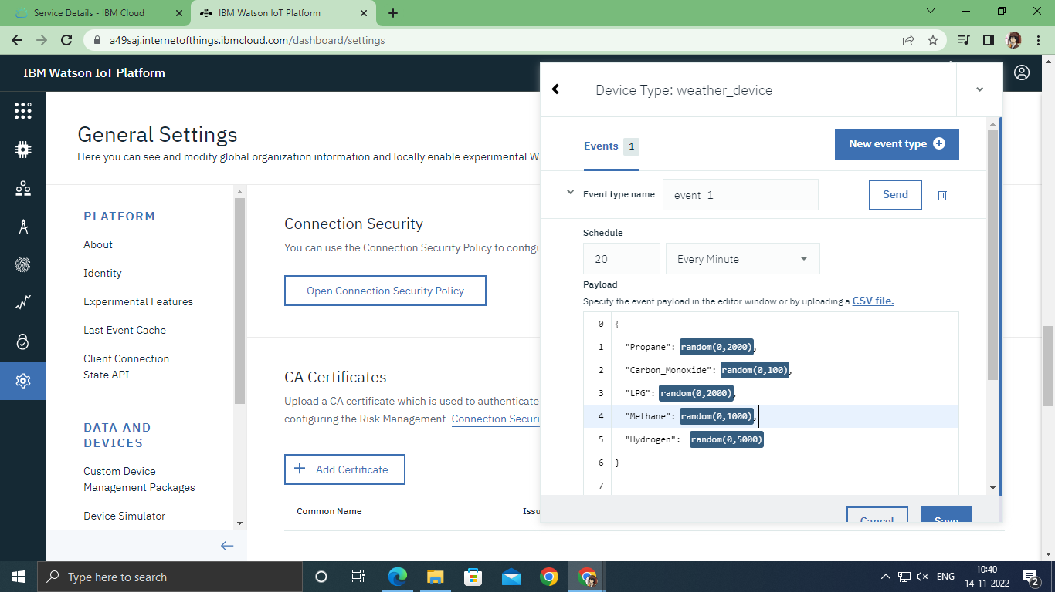

Step 21 : Go to devices then click on devices and check the recent events whether the code is running or not.

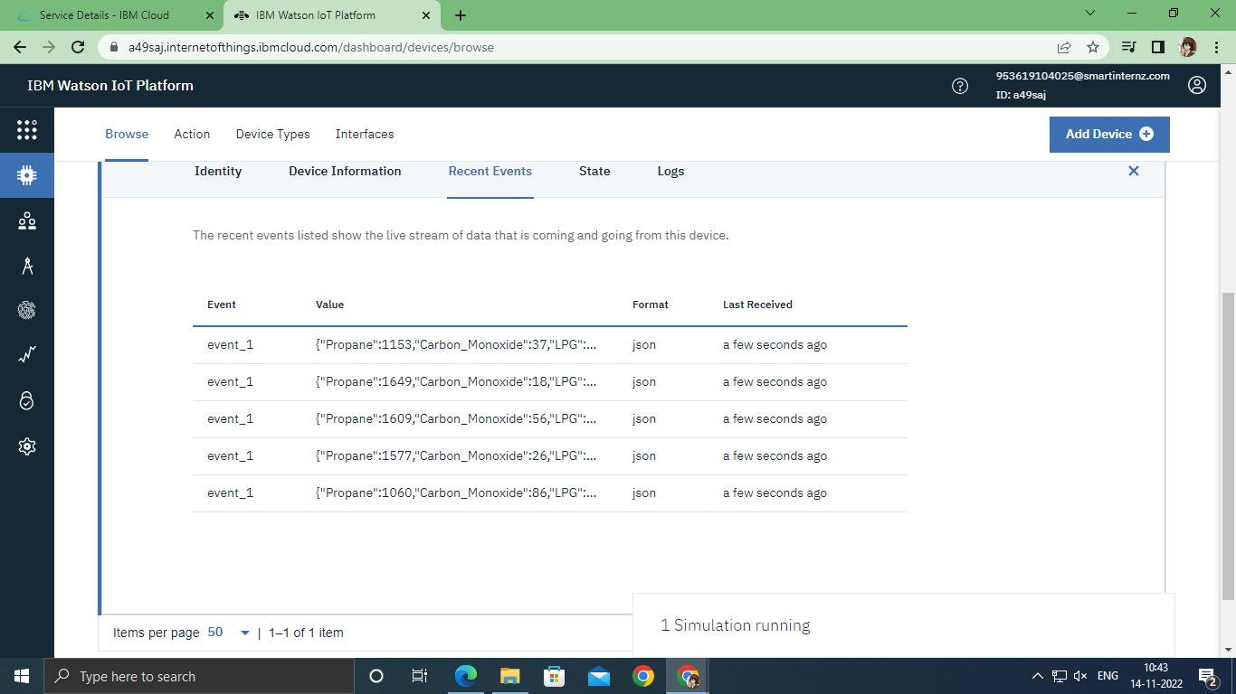

**Result**:

An IBM Watson cloud for IoT and a device is created successfully

# 